VibeVerse

REPORT

SUBMITTED IN PARTIAL FULFILLMENT OF THE REQUIREMENT FOR MINOR PROJECT

**From January to May 2025**

SUBMITTED BY

JAHNAVI ARORA 2202200 145/22

KRITIKA 2202208 153/22

YASHIKA KAPOOR 2202369 170/22

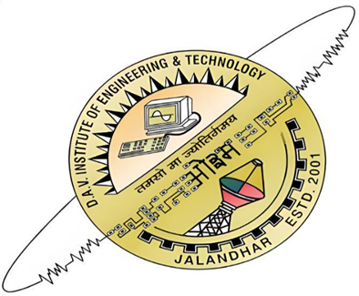

**Department of Computer Science & Engineering**

**DAV Institute of Engineering & Technology Jalandhar, India**

(2022-2026)

**STUDENT DECLARATION**

We hereby declare that the "VibeVerse" project work submitted to DAV Institute of Engineering & Technology, Jalandhar is the record of my original work under the guidance of "Guide Name." The minor project work is submitted in partial fulfilment of the requirement of B.Tech in Computer Science & Engineering. The results included in this project have not been submitted to any other Institute or University. I am solely responsible for these results.

**Name and Signature of the Student’s**

I hereby certify that, I have checked this minor project report and found satisfactory.

**Name and Signature of Project Guide**

I have evaluated the project (“VibeVerse”) on dated ____________ and found satisfactory.

External Evaluator (Name and Signature of HoD)

**Abstract**

VibeVerse is an innovative, multi-functional platform that seamlessly integrates machine learning and real-time data fetching to deliver a personalized multimedia experience. The system offers four interactive modules—Art, Games, Entertainment, and Live News—accessible via a user-friendly home interface.

In the Art section, users can upload any image and apply various artistic transformations such as Pastel Art, Cartoon Art, Watercolor Art, and Pencil Sketch, implemented using torch vision and image processing techniques.

The Games module classifies users into age-based categories—Mature, Teen, Everyone, and Above Ten—and recommends suitable games using machine learning-based recommendation systems.

The Entertainment section provides personalized suggestions for Kdramas, Movies, and Music, tailored to user interests.

Lastly, the Live News section fetches and displays real-time news updates from reliable sources, ensuring users stay informed time-to-time.

By combining creativity, personalization, and utility, VibeVerse offers a unified platform for visual art, entertainment, games and current affairs, showcasing the practical potential of AI and machine learning in everyday digital experiences.

VibeVerse is an AI-powered multimedia platform that merges computer vision, machine learning, and API-based data retrieval to deliver a unified and interactive user experience. The project features four key modules: Art transformation using OpenCV-based filters, a Game recommendation system based on age-group classification, personalized entertainment recommendations (Movies, Music, Kdramas), and live news integration through external APIs. By combining these diverse technologies into a single platform, VibeVerse demonstrates the powerful synergy between media, personalization, and machine learning in real-world applications.

**ACKNOWLEDGEMENT**

I am highly grateful to Dr. Jagjit Malhotra, Principal, DAV Institute of Engineering Technology, Jalandhar, for giving me this opportunity to work on a minor project.

The constant guidance and encouragement received from Dr. Harpreet Kaur Bajaj, HoD Department of Computer Science & Engineering, DAVIET Jalandhar has been of great help in carrying out the project work and is acknowledged with reverential thanks.

I would like to express my gratitude to Ms. Shayana Babbar, Assistant Professor, encouragement and supervision throughout the course of present work. Without the wise counsel and able guidance, it would have been impossible to complete the report in this manner.

I express gratitude to other faculty members of Computer Science & Engineering department of DAVIET for their intellectual support throughout the course of this work.

**Name of the Students**

**List of Figures**

**Fig. No.**  **Figure Description Page No.**

1.1 Entertainment Zone Overview 7

|  |  |  |
| --- | --- | --- |
| 1.2 | Music Recommender UI | 10 |
| 1.3 | DFD Representation | 29 |
| 1.4 | ER Diagram | 11 |
| 1.5 | Main Screen Representation | 51 |
| 1.6 | Art Section Representation | 51 |
| 1.7 | Game Section Representation | 52 |
| 1.8 | News Section Representation | 53 |
| 2.9  3.0 | Media Zone Representation –1  Media Zone Representation -2 | 53  54 |

**TABLE OF CONTENTS**

**Fig. No.**  **Figure Description**  **Page No.**

1.1 Application-Level Firewall 8

|  |  |  |
| --- | --- | --- |
| 1.2 | Stateful Firewall | 9 |
| 1.3 | Packet Filter Firewall | 10 |

**Chapter 1: Introduction**

**1.1 Introduction to Project**

In today’s fast-paced digital world, entertainment is not just a source of leisure but a vital part of everyday life.

With an overwhelming amount of content available online, users often find it challenging to discover quality entertainment tailored to their interests. To address this, we have developed an Entertainment Explorer Website, a one-stop platform designed to enhance the user experience by organizing diverse forms of entertainment into dedicated sections.

This website allows users to seamlessly explore a variety of entertainment categories including Music, Movies, K-Drama, News, Art, and a Gaming Corner. Each section is curated to deliver up-to-date content, personalized recommendations, and interactive features. Whether a user wants to listen to trending songs, catch the latest movie trailers, dive into the world of Korean drama, stay informed with the latest headlines, appreciate visual art, or enjoy fun games—this platform brings it all together in one unified space.

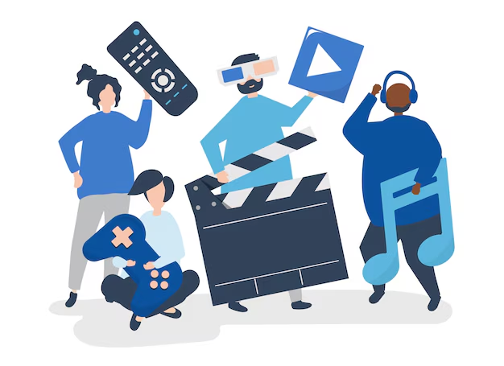

**Entertainment Zone Overview**

**1.2 Project Category (Internet based, Application or System Development, Research based, Industry Automation, Network or System Administration)**

This category involves the design, development, implementation, and deployment of a fully functional software system or application that solves a specific problem or provides a useful service to users.

In Context of our project– a Multi-Domain Recommendation System for Music, Movies, K-Dramas, Games, News, and AI-Generated Art – clearly falls under Application or System Development because we are:

1. **Designing a Complete System:**
   * You're planning the architecture of a system that integrates multiple content domains into a single platform.
   * The system involves front-end interfaces (e.g., web or mobile app) and back-end processes (e.g., recommendation engine, data handling, APIs).
2. **Building an Intelligent Software Application:**
   * You’re implementing machine learning models or algorithms to deliver personalized recommendations.
   * The application handles dynamic data (like news updates, trending games, popular music, etc.).
3. **Integrating Multiple Technologies:**
   * The system uses AI/ML for recommendations, APIs for news/data fetching, possibly cloud services for hosting.
   * Optional integration with AI-generated art tools adds another intelligent module to the system.

**Why Not Other Categories?**

* Internet-based: Could be a secondary category since it likely uses APIs and web hosting, but the core is system development.
* Research-based: While some ML may involve research, your main goal is a working product, not just research.

Your project is primarily an application or System Development project, as it focuses on building a fully integrated software platform that uses artificial intelligence to deliver smart recommendations across various digital content categories, offering real-world utility and interactive features for end-users.

**1.3 Objectives**

The primary objective of the VibeVerse project is to design and develop an intelligent multimedia platform that enhances user interaction by integrating art transformation, personalized recommendations, and real-time information retrieval. The specific objectives of the project are as follows:

1. To build a unified user interface that allows seamless navigation between different modules—Art, Games, Entertainment, and Live News.
2. To implement image transformation techniques using torch vision for generating creative art styles such as pastel art, cartoon effect, watercolor, and pencil sketch from user-uploaded images.
3. To create an age-based game recommendation system that categorizes users and suggests games suitable for their age group (e.g., Teen, Mature, Everyone, Above Ten).
4. To develop a content recommendation system for music, movies, and Kdramas using machine learning and preference-based filtering.
5. To fetch and display real-time live news from reliable online sources using external APIs, keeping users informed with the latest global updates.



**Music Recommender UI**

**1.4 Problem Formulation**

In today's digital age, users are overwhelmed by the sheer volume of content available online across multiple domains such as music, movies, K-dramas, games, news, and digital art. Finding relevant and personalized content from these massive sources has become increasingly difficult and time-consuming. Existing recommendation platforms are often domain-specific (e.g., only movies or music) and lack the ability to deliver unified, cross-domain recommendations tailored to individual preferences.

Moreover, most users consume content across different categories in a single day — such as listening to music, watching a movie, browsing news, or playing games — yet no intelligent system exists that can simultaneously understand a user’s diverse interests and provide a holistic, personalized recommendation experience.

This leads to the following challenges:

* Content Overload: Users struggle to find meaningful content due to the vast availability of choices.
* Lack of Personalization: Generic or non-adaptive recommendation systems fail to align with user preferences.

Problem Statement- How can we develop an intelligent, multi-domain recommendation system that delivers personalized suggestions for music, movies, K-dramas, games, news, and digital art based on user preferences, behaviour, and real-time content trends — all in a unified platform?

**1.5 Identification/Reorganization of Need**

In the modern digital landscape, users interact with a wide range of content types daily — from streaming music and watching movies or K-dramas to playing games, reading news, and engaging with AI-generated art. With the explosion of available content on platforms like YouTube, Netflix, Spotify, online news portals, and art generators, users face difficulty in discovering content that is both relevant and personalized to their tastes.

**Current Gaps:**

* **Content Overload:** The vast and ever-growing pool of digital content overwhelms users, making it hard to make quick and satisfying choices.
* **Domain-Specific Limitations:** Most recommendation engines focus only on one domain (e.g., only music or only news), leading to a fragmented user experience.
* **Lack of Unified Personalization:** There is no centralized system that learns a user's preferences across different content domains and suggests accordingly.

### **Need for a Multi-Domain Recommendation System**

There is a growing demand for a smart, unified, and AI-powered platform that:

* Recommends personalized content across multiple domains (music, movies, K-dramas, games, news, and art).
* Understands user preferences holistically by analysing behaviour across domains.
* Offers real-time, trend-aware, and mood-based recommendations.

### **Reorganized Vision**

To address the above needs, this project aims to develop a centralized recommendation system that integrates:

* Collaborative filtering (based on user behaviour),
* Content-based filtering (based on content similarity),
* And possibly context-aware AI (for trends, time of day, mood, etc.)

This will offer users a seamless and enjoyable experience while exploring various forms of digital content — all from a single, intelligent platform.

**1.6 Existing System**

Currently, most recommendation systems available in the market are domain-specific and operate independently for each type of content. These systems are designed to recommend content like movies, music, games, or news, but rarely combine them into a single, unified platform. While they may use advanced algorithms like collaborative filtering or deep learning, their recommendations are limited to a specific category and do not consider a user's holistic content consumption behaviour.

### Examples of Existing Systems by Domain:

* **Music:**
  + Spotify and YouTube Music use collaborative filtering, listening history, and mood-based playlists to suggest songs.
* **Movies & TV Shows:**
  + Netflix and Amazon Prime Video use user ratings, watch history, and genre preferences to provide personalized movie/show suggestions.
* **K-Dramas:**
  + Viki and Wet suggest K-Dramas based on viewing history but don't combine suggestions with other types of content.
* **Games:**
  + Steam and PlayStation Store provide recommendations based on purchase history and user reviews but only within the gaming domain.
* **News:**
  + Google News and Flipboard personalize news feeds based on reading habits, topics of interest, and location, but do not recommend entertainment content.
* **AI Art:**
  + Platforms like Artbreeder or DeepArt allow users to generate or explore AI-generated art but do not integrate personalized recommendation engines.

### **Limitations of Existing Systems:**

* Operate in isolation with no integration across different content types.
* Cannot learn or adapt to user preferences across multiple domains.

### **Need for Improvement:** There is no existing platform that combines music, movies, K-dramas, games, news, and AI art recommendations into a single, intelligent, user-personalized system — which is the exact gap your project intends to fill.

**1.7 Proposed System**

The proposed system is a unified, intelligent recommendation platform designed to provide personalized suggestions across multiple content domains — including Music, Movies, K-Dramas, Games, News, and AI-Generated Art. Unlike existing systems that focus on a single content type, this system will understand the user's preferences across domains, learn from their interactions, and deliver context-aware, diverse, and personalized recommendations — all within a single platform.

**Key Features of the Proposed System:**

1. **Multi-Domain Integration:**
   * A single system that handles and recommends content across six domains: music, movies, K-dramas, games, news, and art.
2. **Personalized Recommendation Engine:**
   * Uses a hybrid approach combining:
     + Collaborative Filtering (based on similar users)
     + Content-Based Filtering (based on item features)
     + Context-Aware Filtering (based on time, mood, or trends)
3. **User Profile Management:**
   * Builds dynamic user profiles based on interaction history, likes/dislikes, search behaviour, and ratings.
4. **AI-Generated Art Module:**
   * Allows users to explore or generate art using AI models and recommends artwork based on user taste or themes.
5. **Live News Integration:**
   * Fetches real-time news using APIs and recommends news articles based on reading history and preferred topics.

### **Goals of the Proposed System:**

* Enhance content discovery by reducing time spent searching for quality, relevant content.
* Increase user satisfaction by delivering accurate, enjoyable, and meaningful suggestions.
* Create a seamless experience across different content types within a single application.
* Adapt over time as user preferences evolve, becoming smarter with continued use.

**Chapter 2. Requirement Analysis and System Specification**

**2.1 Feasibility study (Technical, Economical, Operational)**

## **1. Technical Feasibility**

Strengths:

* Mature Technology Stack: Modern ML frameworks (TensorFlow, PyTorch, Scikit-learn), hybrid recommender systems (collaborative + content-based + deep learning) are well-documented and proven.
* Data Availability: Datasets for movies (IMDb, TMDb), music (Spotify, Last.fm), games (Kaggle), and news (News APIs) are accessible via public APIs or licensed sources.
* AI Art Generation: Transforms and Vgg19 can be integrated.

**Challenges:**

* Cold Start Problem: New users/items have sparse data. Need contextual or content-based bootstrapping.
* Multi-Domain Complexity: Different user intents and behaviors across music vs movies vs games require careful user profiling and model design.

**Summary**:  
 Technically feasible with current technologies. Needs strong system architecture and careful data handling at scale.

**2. Economic Feasibility**

**Strengths:**

* Multiple Revenue Streams:
  + Affiliate marketing (movies, games, music subscriptions)
  + Premium AI services (e.g., personalized art, deeper insights)
* Startup Costs Manageable:  
  + MVP (Minimum Viable Product) can be built with relatively low-cost cloud services, open datasets, and open-source tools.
  + Later, profits can fund premium infrastructure (e.g., better GPUs, paid APIs).

**Challenges**:

* Scaling Costs: Cloud bills, data licensing (for commercial use), and higher GPU inference loads can become expensive with growth.
* Marketing & Acquisition: User acquisition (ads, SEO, partnerships) can be a major cost if not organic.
* Monetization Timing: Need a critical mass of users first before significant monetization kicks in.

**Summary**:  
Economically feasible at small to mid-scale; needs careful growth planning to prevent burn rate issues.

## 3. Operational Feasibility

Strengths:

* Team Composition Possible: Small team (1-3 developers + 1 marketing/growth person) can manage MVP development and early operations.
* User Engagement Strategies: AI personalization, gamification, reward systems can boost daily active users and retention.
* Platform Flexibility: Web app first, then mobile apps once proven.

Challenges:

* Cross-Domain Personalization: Complex user journeys need careful design (UI/UX) to avoid confusion.
* Moderation & Content Quality: Especially for AI-generated content (art), need moderation pipelines.
* Support & Maintenance: Bug fixes, model retraining, user support will become more demanding as users grow.

Operations Flow Example:

1. Daily model updates (new content ingestion, light retraining).
2. User feedback loop (explicit or implicit) collection.
3. Weekly AI-generated art competitions, events to boost engagement.
4. Content/API monitoring to ensure data freshness (especially news).

Summary:  
 Operationally feasible if started lean with a phased feature rollout strategy.

# **2.2 Software Requirement Specification (SRS) Document**

## **1. Introduction**

This document describes the software requirements for the development of a unified recommendation system that provides personalized suggestions to users across multiple entertainment and information domains such as music, movies, K-dramas, games, news articles, and AI-generated artwork.

## **2. Data Requirement**

## **User Data:**

* + User profiles (name, email, preferences, interaction history).
  + User ratings, likes/dislikes, browsing history.
* **Content Data:**
  + Music, Movie, K-Dramas metadata (title, poster, genre, language).
  + Game metadata (title, genre, platform).
  + News articles (title, source, category).
  + AI Art data (art type).

**APIs:**

* + Third-party APIs to fetch real-time news and trending content.
* **Recommendation Models Data:**  
  + Pre-trained models, collaborative filtering datasets, content-based datasets.

## **3. Functional Requirement**

* **Personalized Content Recommendations:**
  + Generate recommendations based on user behaviour and preferences across multiple domains.
* **User Feedback Collection:**  
  + Allow users to skip recommendations.
* **Content Browsing:**
  + Enable users to explore different categories manually if desired.
* **Real-Time News Updates:**
  + Fetch and display real-time news articles from trusted sources.
* **Cross-Domain Learning:**  
  + Adapt recommendations in one domain based on interactions in another domain.
* **Search Functionality:**  
  + Allow keyword-based search across all domains.

## **4. Performance Requirement**

* **Response Time:**
  + Recommendations and search results must be delivered within 2–3 seconds.
* **System Uptime:**
  + The system should be available 99% of the time.

## **5. Dependability Requirement**

* **Reliability:**  
  + Recommendations must be consistent and relevant over multiple sessions.
* **Fault Tolerance:**  
  + System should handle API failures or network issues gracefully (e.g., fallback mechanisms).

## **6. Maintainability Requirement**

* **Modular Design:**  
  + The system must have a modular codebase to easily update, add, or modify features.
* **Documentation:**
  + Proper documentation (code comments, API docs, user manuals) should be maintained.

## **7. Look and Feel Requirement**

* **User Interface:**  
  + Clean, minimalistic, and visually appealing UI.
  + Use a modern theme with smooth animations and responsive design for mobile and desktop.
* **Navigation:**  
  + Easy-to-use menus and clear categorization of domains (Music, Movies, K-Dramas, Games, News, Art).

**2.3 Validation**

Validation is the process of ensuring that the developed system meets the intended goals, functions correctly, and provides accurate, reliable recommendations according to user needs.

For the Multi-Domain Recommendation System, validation will focus on verifying that the system:

* Accurately predicts user preferences across all six domains (Music, Movies, K-Dramas, Games, News, and AI Art).
* Improves content discovery by reducing the time users spend searching for content.
* Offers relevant, personalized, and context-aware recommendations based on user interaction data.

Validation Methods:

1. User Feedback and Testing:  
   * Conduct user testing where a group of participants uses the system and provides feedback through surveys or interviews.
2. Accuracy Measurement:
   * Measure recommendation accuracy using metrics like:
     + Precision: How many recommended items are relevant.
     + Recall: How many relevant items are successfully recommended.
     + F1 Score: Balance between precision and recall.
3. A/B Testing:  
   * Compare different versions of the recommendation algorithms or UI designs to identify which version offers better performance and engagement.
4. Behavioural Analysis:
   * Track user engagement metrics such as click-through rates, time spent exploring recommendations, and the frequency of using different domains.
   * Analyze whether the system correctly adapts over time based on user actions.
5. Load and Performance Testing:
   * Test the system’s speed and responsiveness when dealing with multiple recommendation requests and real-time content fetching (especially for live news and trending data).
6. Cross-Domain Correlation Checking:  
   * Validate that the system intelligently learns from a user's activity in one domain (e.g., movies) to enhance recommendations in another domain (e.g., games or music).

Validation Goal:

To ensure that the recommendation system provides highly relevant, personalized, diverse, and seamless content suggestions across all targeted domains, enhancing user satisfaction and engagement.

**2.4 Expected hurdles**

1. Data Collection and Quality  
   * Collecting large, clean, and diverse datasets for music, movies, K-dramas, games, news, and art is very challenging.
   * Different sections require completely different formats (e.g., numeric ratings for movies, genre tags for music, text descriptions for art).
2. Cold Start Problem  
   * New items (new songs, new games, newly released news articles) might not have enough user feedback to recommend properly.
3. Personalization Across Different Categories  
   * User preferences vary greatly across sections. Someone might like action movies but prefer romantic K-dramas and strategic games.
   * Building a recommendation logic that understands different tastes for each category is complex.
4. Handling Subjectivity and Trends  
   * Trends in music, movies, news, and even art change rapidly.
   * The system needs mechanisms to stay updated and handle real-time trend shifts while maintaining personalization.

**2.5 SDLC model to be used**

For the development of the VibeVerse project, we have chosen the Prototype Model of the Software Development Life Cycle (SDLC).

The Prototype Model is suitable for projects where requirements are not completely clear at the beginning and can evolve based on user feedback. It involves creating a working prototype of the system early in the project. The prototype is shared with users to gather feedback, which helps in refining the requirements and improving the system.

In our project, Vibeverse, we first designed the basic user interface with four main categories: Art, Games, Entertainment (Music, Movies, K-Dramas), and Live News. Based on this foundation, we continued to add features such as:

* Uploading an image and applying different artistic styles using OpenCV (Pastel Art, Cartoon Art, Watercolor Art, Pencil Sketch).
* Game recommendations based on different user age groups (Everyone, Teen, Mature).
* Entertainment recommendations including music, movies, and K-Dramas.
* Live news updates for real-time information.

Throughout the development process, continuous testing and feedback were taken to improve user interaction, design flow, and feature quality.

Thus, the Prototype Model was the most effective choice because it allowed:

* Flexibility to modify features according to suggestions.
* Faster identification of missing functionalities

**Chapter 3. System Design**

**3.1 Design Approach (Function oriented or Object oriented)**

For this project, the chosen design approach is Object-Oriented Design (OOD).

### Reason for Choosing Object-Oriented Design:

* Modularity:  
  + Each content domain (Music, Movies, K-Dramas, Games, News, Art) can be represented as separate classes or modules with their own attributes and methods.
* Reusability:  
  + Common features like "Content," "Recommendation," "User Profile," and "Search" can be reused across domains with inheritance and polymorphism.
* Scalability:  
  + Easy to add new content types (e.g., Podcasts, Books) in the future without major changes to the system.
* Maintainability:  
  + Updating or fixing bugs in one module (like the News Recommendation Module) does not affect others.
* Real-World Mapping:  
  + Users, Content, and Recommendations are real-world entities that map naturally to objects.

Basic Object-Oriented Structure:

* Classes Example:  
  + User
  + Music, Movies, K-Dramas
  + Game
  + NewsArticle
  + ArtPiece
  + RecommendationEngine
  + SearchEngine

Each class would have its own attributes (like title, genre, poster, etc.) and methods (like recommend (), fetch news(), etc.).

### Alternative Option is Function-Oriented Design:

* Function-oriented design (like flowcharts and DFDs) could be used for very small, procedural systems.
* But for a complex, multi-domain, scalable system like this, Object-Oriented Design is more suitable and future-proof.

# Conclusion:

The project will be developed using an Object-Oriented Design Approach to ensure modularity, flexibility, reusability, and scalability.

**3.2 Detail Design**

**1. Overall System Architecture**

* The system follows a modular, object-oriented architecture.
* It is divided into three main layers:  
  1. **Presentation Layer (Frontend):**  
     + Handles user interface, displays recommendations, collects user actions.
  2. **Application Layer (Backend Logic):**  
     + Processes user requests, generates recommendations, manages user profiles.

## **2. Main Classes and Their Description**

|  |  |
| --- | --- |
| **Class Name** | **Description** |
| **User** | Represents a user. Stores preferences, history, and profile data. |
|  |  |
| **Music** | Inherits ContentItem. Additional attributes: poster, name, genre. |
| **Movie** | Inherits ContentItem. Additional attributes: poster, cast, name. |
| **KDrama** | Inherits ContentItem. Attributes: synopsis, name, season. |
| **Game** | Inherits ContentItem. Attributes: platform, genre, release date. |
| **News Article** | Inherits ContentItem. Attributes: source, published date, category. |
| **Art Piece** | Inherits ContentItem. Attributes: style, AI model used, tags. |
| **Recommendation Engine** | Core class that generates personalized recommendations. |
|  |  |
| **SearchEngine** | Supports keyword-based search across all domains. |
| **Admin** | Manages content, monitors system usage, updates content manually if needed. |

## **3. Relationships Between Classes**

* ContentItem is an abstract class extended by specific types like Music, Movie, etc.
* RecommendationEngine uses user data + content data to suggest ContentItem.
* FeedbackManager modifies user profile preferences based on interactions.
* Admin manages system-wide data and content addition.

**3.3 System Design using various Structured analysis and design tools such as: DFD’s, Data Dictionary, Structured charts, Flowcharts**

In building the Entertainment Exploration Website, system design plays a critical role in ensuring a smooth, efficient, and user-friendly experience. To achieve this, several structured analysis and design tools have been utilized. These tools help in logically organizing the system's processes, data flow, and structure. The key tools used are:

### **Data Flow Diagrams (DFDs)**

**Data Flow Diagrams (DFDs)** represent how data moves within the system. They show the interaction between users (external entities), processes, and data stores. For the entertainment website:

* **Level 0 DFD (Context Level):**  
   Shows the website as a single process where users interact to access music, movies, art, and news.
* **Level 1 DFD:**  
   Breaks down the main process into sub-processes:  
  + Music Zone Access
  + Movies Zone Access
  + Art Gallery Exploration
  + News Updates Browsing
* **Level 2 DFD:**  
   Provides deeper details such as:  
  + Search and Recommendation engine
  + Content Management System for admins

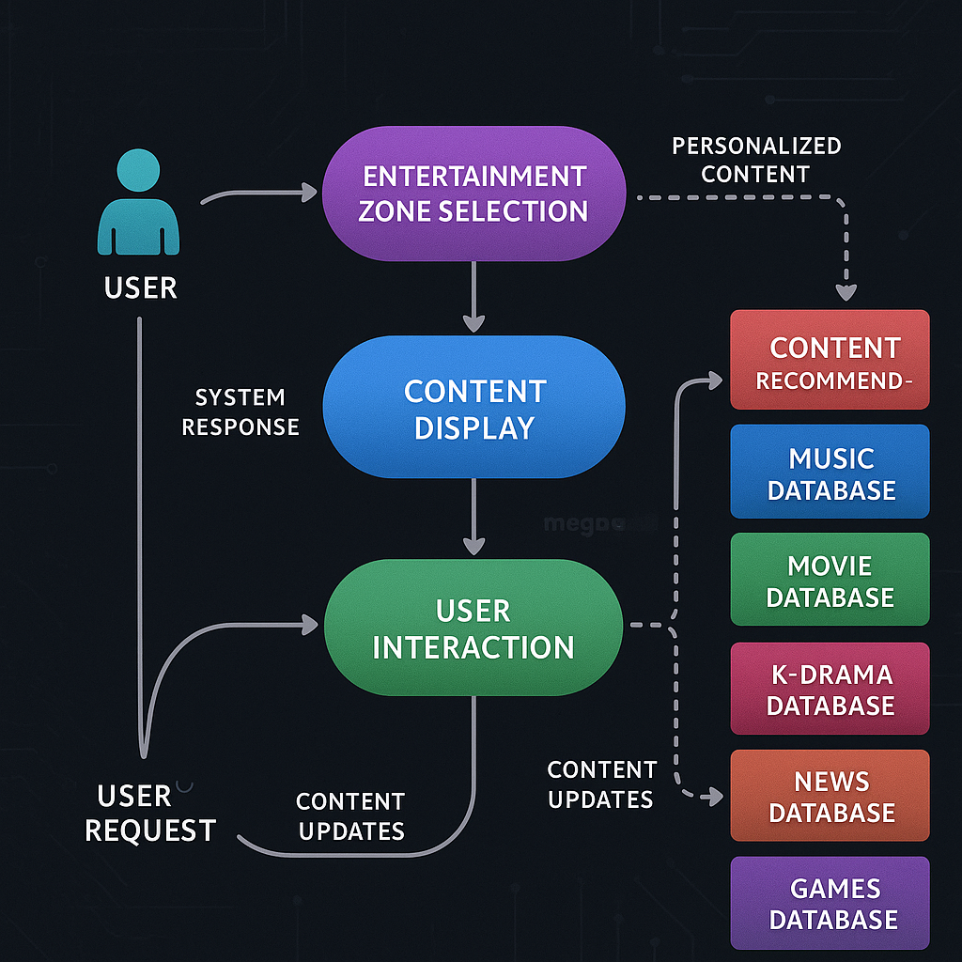

**DFD Representation**

### **Data Dictionary**

The **Data Dictionary** defines and describes the key data elements used in the system, ensuring clarity and consistency. Examples for this website include:

|  |  |  |  |
| --- | --- | --- | --- |
| **Data Element** | **Description** | **Type** | **Size** |
|  |  |  |  |
| Zone_Type | Category type (Music, Movies, Art, News) | String | 15 |
| Search_Query | Keywords entered by the user | String | 100 |

**3.4 User Interface Design**

## **1. Design Goals**

* Simple and intuitive navigation for users of all ages.
* Personalized experience based on user preferences.
* Modern and aesthetic look with smooth transitions and minimalistic layout.
* Consistency in design across different sections (Music, Movies, Games, etc.).
* Responsiveness — compatible with desktops, tablets, and mobile devices.

## **2. Main Screens and Their Layouts**

* **Header:**  
  + Search bar (center)
* **Navigation Menu:**  
  + Horizontal or side navigation for: Home | Music | Movies | K-Dramas | Games | News | Art
* **Main Area:**  
  + "Recommended For You" — A carousel of personalized content across domains.

### **Music Section**

* **Categories:** Genres (Pop, Rock, Hip-Hop, K-Pop, etc.)
* **Playlist Recommendations:** Based on user mood or listening history.
* **Player:** Embedded audio player with play option.

### **Movies Section**

* **Categories:** Genre (Action, Romance, Thriller, Comedy, etc.)
* **Movie Cards:** Title, thumbnail, short description, rating.

### **K-Drama Section**

* **Drama Info:** Description, cast, genre, synopsis.

### **Games Section**.

* **Game Suggestions:** New releases, trending, based on user interests.
* **Game Info:** Cover image, description, genre.

**News Section**

* **Top News:** Carousel of trending news.
* **Categories:** World, Technology, Entertainment, Sports.

**Art Section**

* **Explore AI Art:**  
  + View AI-generated artworks.
* **Generate Your Art:**  
  + Upload images or choose a style to generate new art.
* **Unified Search:** Search across all domains.
* **Filters:** Domain type, genre, rating, date.
* **Instant Suggestions:** As the user types, show relevant content.

**3.5 Database Design**

Database diagrams are visual representations that illustrate the structure of a database.

They show how tables are connected, what fields exist in each table, and how relationships (like one-to-many, many-to-many) are formed between different entities.

**3.5.1 ER Diagrams**

An Entity-Relationship (ER) Diagram is a type of flowchart that illustrates how entities such as people, objects, or concepts relate to each other within a system.

**ER Diagram**

**3.5.2 Normalization**

In the context of an entertainment website with multiple categories (Art, News, Music, Movies, and K-Dramas), normalization techniques help to manage a large volume of varied data while maintaining quality, speed, and reliability.

* **Reduces Data Redundancy**: Information like artist names, genres, posters etc. are stored only once.
* **Ensures Data Integrity**: Any update in one place (e.g., changing an artist's name) reflects across the website.
* **Improves Query Performance**: Fetching and filtering content becomes faster.

**3.5.3 Database Connection Controls and Strings**

A database connection is the link between a software application (like our entertainment website) and a database (like MySQL, PostgreSQL, or SQLite). A connection string is a single line that includes all the connection details. Instead of passing each parameter separately, you can combine them into one string. In our website, the system is designed for user interaction and exploration of various entertainment sections, such as music, movies, K-dramas, news, art, and games. So, there is no need for a database connection. All the content is either preloaded, static, or fetched dynamically (if APIs are used), so there is no storage or retrieval of user data, login information, or persistent records. As a result, the project operates without using a backend database, ensuring a lightweight and fast user experience.

**3.6 Methodology of system**

## **1. Problem Identification**

* Users have access to a huge amount of digital content (music, movies, games, news, etc.), making it difficult and time-consuming to find content they truly like.
* A unified recommendation system is needed that can provide personalized suggestions across multiple domains (Music, Movies, K-Drama, Games, News, and AI Art).

## **2. System Requirements Gathering**

* **Understand what users want:**  
  + Personalized recommendations
  + Fast search and browsing
  + Cross-domain suggestions (e.g., suggest a movie after liking a song)
* **Gather technical requirements:**  
  + Frontend (User Interface)
  + Backend (Recommendation Engine, APIs)

**3. System Design**

### **a) Architecture Design**

* A three-layer architecture:  
  + Frontend (UI/UX): Built using web technologies (React, HTML, CSS).
  + Backend (Logic/Server): Built using Python/Node.js to handle recommendation algorithms and APIs.

### **b) Object-Oriented Design (OOD)**

* Each major domain (Music, Movies, Games, News, Art) is modeled as a class.
* Users, content items, and recommendation engines interact through defined methods and relationships.

## **4. Development Method**

### **a) Content Collection**

* Gather datasets for:  
  + Music (songs, albums, artists)
  + Movies (titles, genres, ratings)
  + K-Dramas (titles, networks, actors)
  + Games (titles, platforms, genres)
  + News (fetched live from news APIs)
  + Art (AI-generated images)

### **b) Recommendation System Development**

* Use a Hybrid Recommendation Approach:  
  + Collaborative Filtering (user-to-user or item-to-item similarity)
  + Content-Based Filtering (recommend based on content features)
  + Context-Aware Recommendations (based on time, mood, popularity)
* **For News and Art:**  
  + API integration (fetching latest news articles)
  + AI Art Generation APIs or models for user-created content.

## **5. Implementation**

* **Frontend Development:**  
  + Responsive UI to display recommendations neatly.
* **Backend Development:**  
  + APIs to serve recommendations and accept user feedback.

## **6. Testing**

* Unit Testing: Test each module individually (Recommendation Engine, Search Engine, User Feedback Handling).
* Integration Testing: Test the interaction between frontend, backend.
* User Acceptance Testing (UAT): Test with real users to see if the system meets their expectations.

## **7. Deployment**

* Host the system on a cloud platform (AWS, Azure, or even Firebase for a smaller version).
* Connect frontend, backend in production environment.

## **8. Maintenance and Improvement**

* Collect real usage data after deployment.
* Continuously improve the recommendation algorithms based on real user feedback.

## 

## **Chapter 4. Implementation, Testing and Maintenance**

### **4.1 Introduction to Languages, IDEs, Tools, and Technologies Used for Implementation**

In the development of the Vibeverse project, various programming languages, Integrated Development Environments (IDEs), tools, and technologies were used to implement and optimize the features of the system. Below is a brief overview of the core technologies used in the project:

#### **1. Python**

Python is the main programming language employed in this project. Known for its ease of use and wide-ranging libraries, Python is particularly effective for data processing, machine learning, and artificial intelligence. Python's simplicity allows for quick development, and its rich ecosystem makes it suitable for handling complex tasks such as image processing, machine learning models, and web-based applications.

Key Python libraries used:

* **OpenCV (cv2)**: OpenCV, or cv2, is an open-source computer vision library used for various image processing tasks. In this project, OpenCV was used to apply different artistic styles (Pastel Art, Cartoon Art, Watercolor, Pencil Sketch) to images uploaded by users. OpenCV provides efficient and optimized functions for manipulating and transforming images, making it a perfect choice for such tasks.
* **TensorFlow**: TensorFlow is an open-source machine learning library developed by Google. It was used for building deep learning models for recommendations and other advanced functionalities. TensorFlow enabled us to develop models for personalized content recommendations, improving the user experience.
* **Scikit-learn**: Scikit-learn is a machine learning library that provides simple and efficient tools for data analysis and modeling. It was utilized in the project for implementing recommendation systems (games, music, movies) and other machine learning tasks like classification and clustering.

#### **2. Streamlit**

Streamlit is an open-source framework for building interactive web applications. It allows for easy integration with Python and other libraries to quickly prototype and deploy machine learning models. For this project, Streamlit was used to create the user interface, enabling users to interact with the application, upload images for art transformation, receive recommendations, and access live news updates.

#### **3. cv2 (OpenCV)**

As mentioned, OpenCV (cv2) is one of the main libraries used for image manipulation in this project. It allows us to apply various artistic effects to the uploaded images. The real-time manipulation capabilities of OpenCV make it an indispensable tool for image processing tasks in the Vibeverse project.

#### **4. urllib**

The urllib library in Python is used for working with URLs, fetching data from the internet, and handling HTTP requests. In this project, urllib was crucial for fetching live news data from external APIs and ensuring that the news section in the application remains up-to-date with the latest information. It allows the system to interact with web resources and integrate real-time content.

#### **5. Jupyter Notebooks**

Jupyter Notebooks is an open-source web application used for creating and sharing documents that contain live code, equations, visualizations, and narrative text. During the development of this project, Jupyter Notebooks was used primarily for experimenting with machine learning models, testing algorithms, and visualizing data.

**6. IDEs (Integrated Development Environments)**

For coding and development, the following IDEs were used:

* **VS Code (Visual Studio Code)**: A versatile and lightweight code editor, VS Code was used to write Python code for the project. It supports various extensions for Python, making it easier to code, debug, and manage the project efficiently.
* **Jupyter Notebooks**: Used for testing, experimenting, and visualizing machine learning models and data analysis workflows before they were integrated into the main application.

**4.2 Coding Standards of Language Used**

In the development of the Vibeverse project, adherence to coding standards was essential to ensure the code is clean, readable, and maintainable. The following coding standards and practices were followed for the primary language, Python, and its associated libraries and frameworks.

#### **1. PEP 8 (Python Enhancement Proposal 8)**

The project strictly followed PEP 8, which is the official style guide for Python code. This ensured that the code follows widely accepted conventions for readability and structure. Key aspects of PEP 8 that were adhered to include:

* **Indentation**: Consistent use of 4 spaces for indentation.
* **Line Length**: Limiting lines to a maximum of 79 characters to ensure readability, especially when viewing code in side-by-side comparisons or diffs.
* **Blank Lines**: Proper use of blank lines to separate top-level functions and class definitions and to separate logical sections of the code within functions.
* **Imports**: Imports are organized and placed at the beginning of files. Standard library imports are followed by third-party library imports, and then local imports.
* **Naming Conventions**: Consistent naming of variables, functions, and classes following the snake_case convention for variables and functions and CamelCase for class names.

#### **2. Commenting and Documentation**

Effective commenting and documentation were critical in maintaining clarity and ensuring that the code could be easily understood by team members and other stakeholders.

* **Inline Comments**: Comments were used to explain sections of code where the logic might not be immediately clear. These comments were brief and focused on describing the purpose and function of the code.
* **Docstrings**: Each function, class, and module included a docstring to provide a clear explanation of what it does, its input parameters, and expected output. This ensured that anyone reviewing the code could quickly understand its functionality.

#### **3. Code Readability and Structure**

A focus on readability was key to making the codebase maintainable. The following principles were followed to ensure the clarity of the code:

* **Logical Flow**: The project was divided into modules that each performed specific tasks. This structure made the project easier to understand and maintain.
* **Consistent Style**: The entire team followed a uniform style for writing the code, ensuring that similar tasks were handled in a consistent manner across different parts of the project.
* **Error Handling**: Robust error handling was implemented to gracefully handle unexpected issues, such as invalid input or unavailable resources, which ensured a smooth user experience and code stability.

#### **4. Code Optimization and Efficiency**

To ensure the project could scale and run efficiently, attention was paid to optimizing the code:

* **Efficient Algorithms**: Optimized algorithms and data structures were used, particularly in tasks such as machine learning model training and image processing. Efficient implementation of algorithms helped improve the performance of the system.
* **Memory Management**: Memory usage was carefully managed, especially when processing large datasets or images. This ensured the project could handle larger inputs without performance degradation.

#### **5. Version Control and Collaboration**

The project made use of Git for version control, ensuring that the code was tracked, changes were documented, and collaboration among team members was smooth. The following best practices were followed:

* **Regular Commits**: Changes to the codebase were committed frequently with meaningful commit messages that explained the purpose of each change.
* **Branching Strategy**: A branching strategy was used to separate development of new features or bug fixes from the main codebase. Features were developed on separate branches and merged after thorough testing.

#### **6. Testing and Debugging**

Ensuring the correctness of the code was a priority, and testing was performed regularly to identify and resolve issues. Automated testing frameworks were used where applicable, and debugging tools were employed to quickly fix any bugs.

### **4.3 Testing Techniques and Test Plans**

Testing is a crucial aspect of the Vibeverse project to ensure that the system works as expected, provides a smooth user experience, and handles all possible edge cases. The goal of testing is to identify and fix any defects before the system is deployed. Below is a breakdown of the testing techniques used and the test plan followed to validate the various components of the system.

#### **1. Testing Techniques Used**

To ensure the quality and reliability of the **Vibeverse** project, the following testing techniques were implemented:

* **Unit Testing**: Unit testing was used to verify that individual components or functions in the project worked as intended. Each function was tested in isolation to ensure it produced the correct output for different input values. For example, the image preprocessing function was tested for different image sizes and formats to ensure consistency in output.
* **Integration Testing**: Integration testing was performed to ensure that different modules and components of the system worked together seamlessly. For example, the integration of the image processing module (using OpenCV) with the machine learning module (using Scikit-learn and TensorFlow) was tested to ensure that the outputs were properly communicated between the modules and the system worked as a whole.
* **User Interface Testing**: The user interface, built using Streamlit, was tested to ensure it was intuitive and user-friendly. This testing involved checking that the buttons, inputs, and other UI elements responded correctly to user interactions and that the interface was consistent across different devices.
* **Functional Testing**: Functional testing was used to verify that the system's features and functions worked as per the requirements. This included testing the game recommendation system, music and movie recommendation systems, and the art effects (such as cartoon art, watercolor art, etc.) to ensure that the user input led to the correct outputs.
* **Performance Testing**: Performance testing was conducted to assess the efficiency and speed of the application, particularly when handling large images or multiple user requests. This testing ensured that the system could handle heavy loads without significant slowdowns or crashes.
* **Security Testing**: Since the project allows users to upload images and interact with external APIs (for live news and recommendations), basic security testing was performed to ensure that user inputs were validated and that the application was protected from common vulnerabilities such as SQL injection or Cross-Site Scripting (XSS) attacks.
* **User Acceptance Testing (UAT)**: User acceptance testing was carried out by a small group of users to evaluate the system's functionality and usability in real-world scenarios. Feedback from users was gathered to refine and improve the project before its final deployment.

#### **2. Test Plan**

The following test plan outlines the strategy and the steps that were followed to test the Vibeverse project:

##### **Test Plan Overview:**

* **Objective**: The objective of the test plan is to ensure the correct functionality of the system, identify defects, and ensure that the system meets the user requirements.
* **Scope**: This test plan covers the testing of all major modules, including image processing, game recommendations, music and movie recommendations, art effects, and live news features.
* **Test Environment**: The tests were performed in a development environment using Python 3.x, Streamlit, TensorFlow, Scikit-learn, CV, and other necessary dependencies installed locally. The application was accessed via a web browser for user interface testing.
* **Test Cases**: The following types of test cases were defined and executed:  
  + **Functionality Tests**: Each feature of the application was tested to ensure it worked as expected. For example, uploading an image and applying different art effects (pastel, cartoon, watercolor).
  + **Edge Case Tests**: Tests were performed on edge cases, such as uploading very large or corrupted images, or selecting an invalid category from the recommendation system.
  + **Load Tests**: Tests were conducted to simulate multiple users accessing the system simultaneously to see how it performed under stress.
  + **Security Tests**: Tests to ensure that user inputs were sanitized and there were no vulnerabilities in the system.
  + **Compatibility Tests**: The application was tested on different browsers and devices to ensure compatibility across various platforms.

##### **Test Cases Overview:**

* **Image Upload and Processing**:  
  + Verify that the system accepts images in different formats (JPEG, PNG, etc.).
  + Test image size limits (e.g., upload an image that exceeds the size limit).
  + Check that the correct art effect (e.g., watercolor, cartoon) is applied to the uploaded image.
* **Recommendation System**:  
  + Test the game recommendation feature by selecting different categories (Mature, Teen, Everyone).
  + Ensure that the movie, music, and K-drama recommendation systems return appropriate suggestions based on user preferences.
* **Live News**:  
  + Test the live news feature by ensuring that it fetches the latest news correctly from external sources.
  + Check that the news displayed is relevant and updated regularly.

##### **Test Execution:**

* **Test Schedule**: Testing was conducted in phases, starting with unit testing during the development process, followed by integration testing and user interface testing.
* **Test Resources**: The testing team consisted of developers and a small group of end-users who provided feedback during user acceptance testing.
* **Test Reporting**: All test cases were documented with expected results, actual results, and any issues encountered. Defects were tracked and addressed before the final release.

#### **3. Bug Tracking and Issue Resolution**

A bug-tracking system was used to log and track issues found during testing. All identified issues were categorized based on their severity, and they were resolved before the system was considered ready for deployment.

**Chapter 5. Results and Discussions**

**5.1 User Interface Representation**

## **1. Landing Page**

* **Look:** Clean and minimal with background art or soft color gradient.

## **2. Home Page (Personalized Dashboard)**

* **Top Navigation Bar:**  
  + Home | Music | Movies | K-Dramas | Games | News | Art
* **Main Sections:**
  + **Search Bar:**
    - Centered at the top.
  + **Recommended For You:**
    - Carousel style recommendations across domains.

## **3. Category Pages (Music / Movies / K-Drama / Games / News / Art)**

* **Common Layout for All Categories:**  
  + **Sidebar (optional for desktop):** Filter by genre, popularity, release year.
  + **Content Display Area:**
    - Grid view of items.
    - Each item card shows:
    - Thumbnail image
      * Title
      * Short description

## **4. Detailed Content Page (Individual Item View)**

* When user clicks an item (song/movie/game/news/article):
  + Large poster/image/banner at the top.
  + Title, author/artist, genre, release date.
  + Play/Recommend button.

**5.1.1 Brief Description of Various Modules of the System**

The **Vibeverse** project is structured into multiple functional modules, each responsible for a specific feature of the system. Below is a brief description of each module:

### **1. Home Page Module**

* This is the landing page where the user is welcomed and presented with four main options:
  + Art
  + Games
  + Entertainment (Music, Movies, K-Drama)
  + Live News
* The design ensures simple navigation and smooth user experience using Streamlit.

**2. Art Module**

* In the **Art** section, users can upload an image.
* After uploading, they are given four options to apply different artistic effects:  
  + **Pastel Art**
  + **Cartoon Art**
  + **Watercolor Art**
  + **Pencil Sketch**
* Image transformations are performed using  **cv2** and custom filters.
* Each effect provides a different aesthetic, enhancing the creative aspect of the uploaded images.

### **3. Game Recommendation Module**

* The Games module recommends suitable games based on the selected category:  
  + Mature
  + Teen
  + Everyone Above 10
  + Everyone
* Recommendations are generated using a predefined dataset and machine learning techniques.
* The model suggests appropriate games considering age group and preference.

### **4. Entertainment Recommendation Module (Music, Movies, K-Drama)**

* This module helps users discover entertainment content based on their interests.
* Users can choose between:  
  + Music Recommendations
  + Movie Recommendations
  + K-Drama Recommendations
* A content-based recommendation system is used to suggest relevant options.
* Machine learning models (built using Scikit-learn and TensorFlow) analyze preferences and generate personalized recommendations.

### **5. Live News Module**

* In the Live News section, users get access to real-time news updates.
* Latest news is fetched using APIs and libraries like urllib.
* The news is displayed dynamically within the Streamlit interface, ensuring users stay updated.

### **6. Backend Processing Module**

* Handles all the data processing, model predictions, and image transformations.
* Manages loading models, preprocessing user inputs, and returning results.
* Built using Python, Machine Learning Libraries, and Streamlit.

### **7. User Interface (UI) Module**

* Developed using Streamlit to create a responsive, interactive, and visually appealing web application.
* Responsible for handling user interactions, displaying results, and maintaining a smooth flow between modules.

**5.2 Snapshots of system with brief detail of each**

* **Main Screen**

The Main Screen serves as the central hub of the website, offering easy access to all entertainment zones — Music, Movies, K-Dramas, News, Art, and Games.

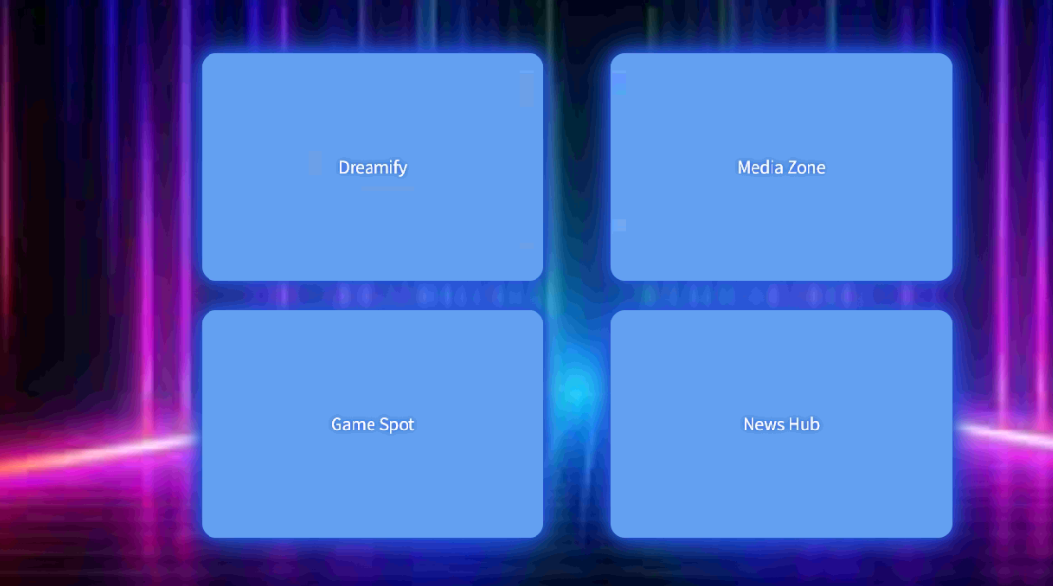



* **Art Module ( Dreamify)**

The Art Module offers a dynamic space for users to explore the world of creativity. With a wide range of artworks, and modern designs, this module encourages users to dive deep into different artistic styles. It’s designed to inspire imagination, promote creativity, and provide a visually engaging experience by converting an image to different types of arts.

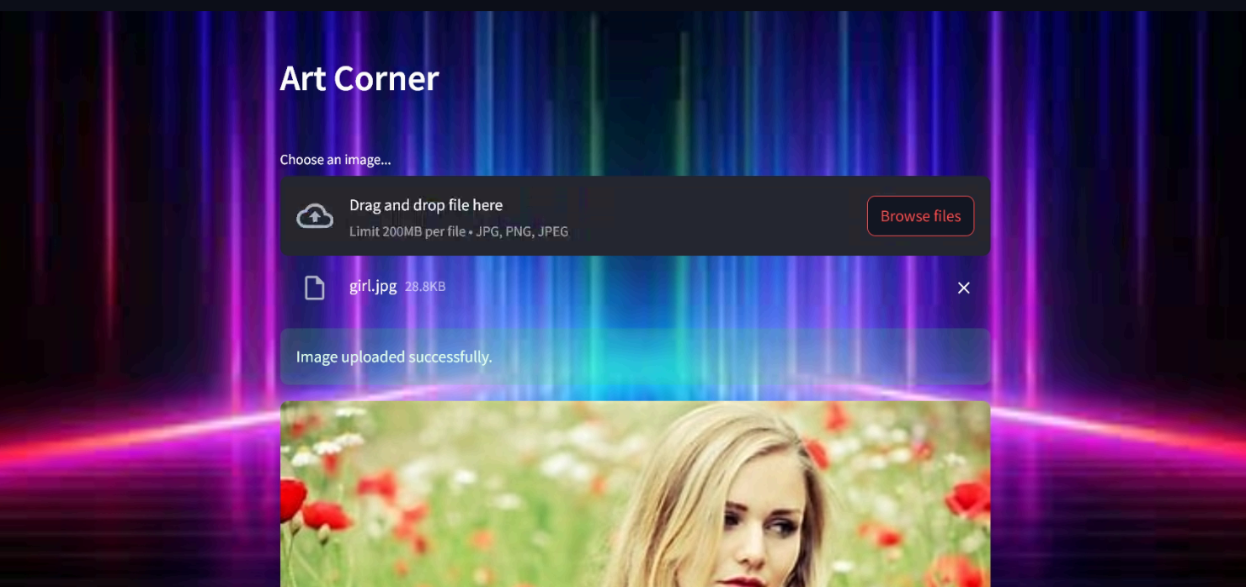

**Art Section Representation**

* **Game Module (Game Spot)**

The Game Module is a thrilling space designed for users who love adventure, strategy, and fun. It offers a variety of games that range from action-packed challenges to relaxing puzzles, providing something for every type of gamer.

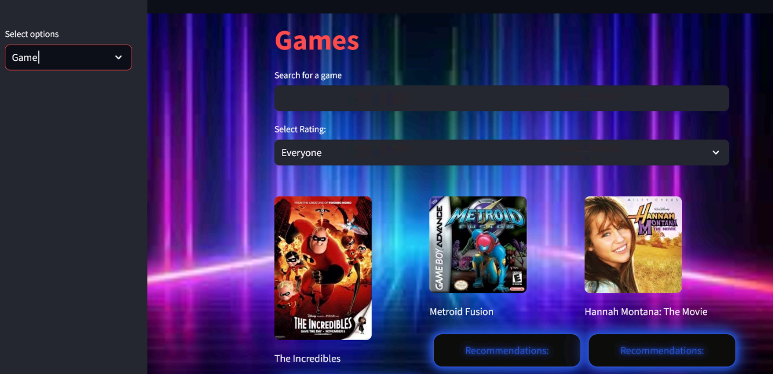

**Game Section Representation**

* **News Module(News Hub)**

The News Module keeps users connected to the latest updates from around the world. Covering trending topics, current events, entertainment news, and more, it provides quick and easy access to important information.

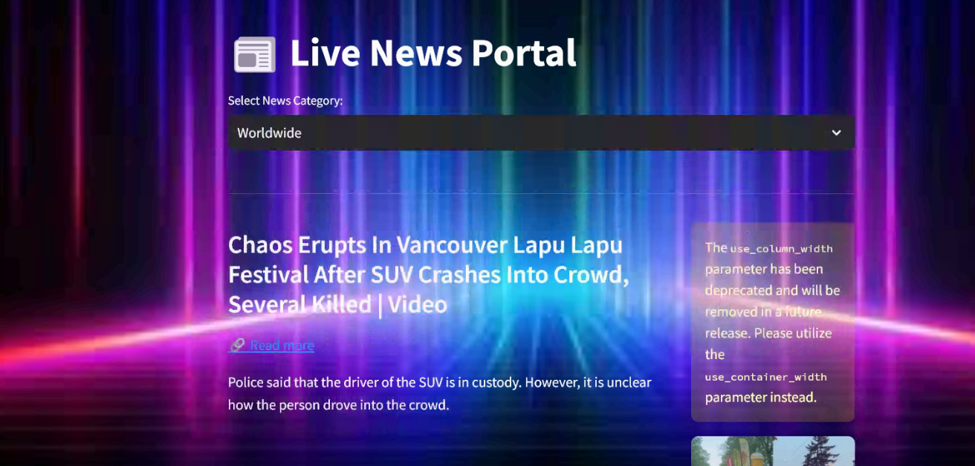

**News Section Representation**

* **Music, Movies, K-Dramas Module ( Media Zone)**

The Screen brings together the best of Music, Movies, and K-Dramas into one vibrant space. Users can easily explore trending songs, blockbuster movies, and the latest K-Drama hits, all from a single platform.

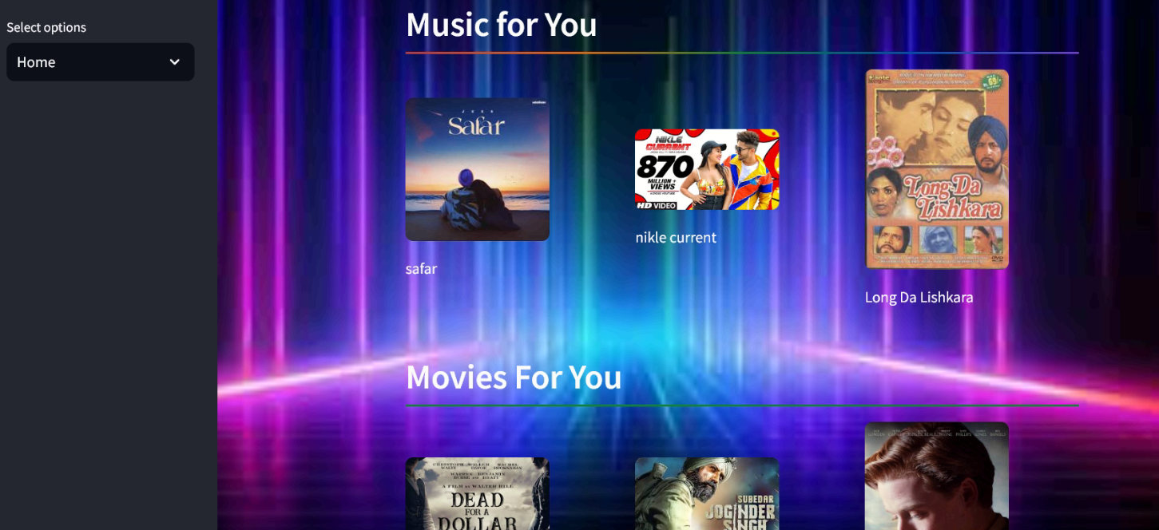

**Media Zone Representation -1**

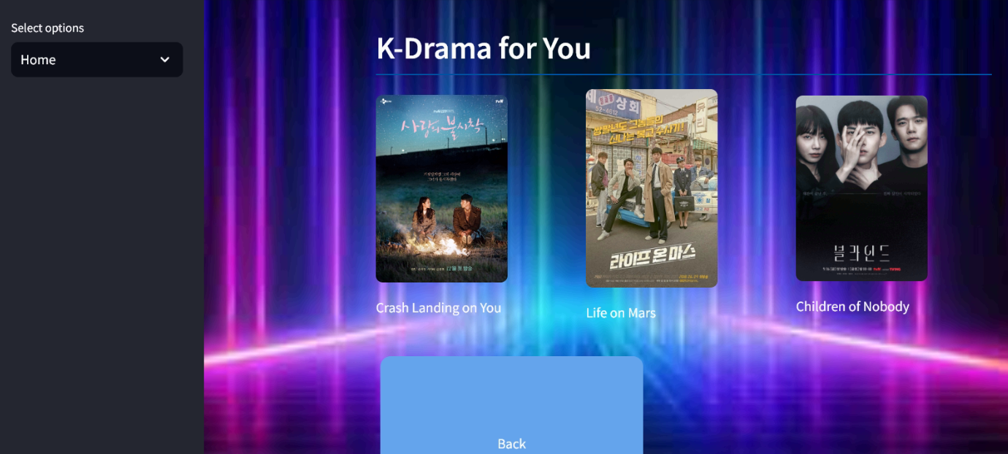

**Media Zone Representation -2**

**Chapter 6. Conclusion and Future Scope**

In this project, we developed a unified Recommendation System that provides personalized suggestions across multiple domains such as Music, Movies, K-Dramas, Games, News, and AI Art. The system leverages a hybrid recommendation approach combining collaborative filtering, content-based filtering, and context-aware techniques to deliver highly relevant recommendations to users. The user-friendly interface ensures smooth navigation and seamless discovery of diverse content. By tracking user preferences and interactions, the system continuously improves its recommendations, offering a highly personalized experience.  
 Overall, this project successfully addresses the growing need for an integrated platform that simplifies digital content discovery in an era of information overload.

# **Future Scope**

1. **Expansion to More Domains:**  
   * Include Educational Courses and Social Media recommendations.
2. **Use of Advanced AI Models:**  
   * Integrate Deep Learning models like Neural Collaborative Filtering (NCF) and Reinforcement Learning to further improve recommendation quality.
3. **Voice-Based Recommendations:**  
   * Add voice assistant support (like Alexa or Google Assistant) to allow users to discover content through voice commands.
4. **Cross-Platform Availability:**  
   * Develop mobile apps (Android/iOS) and browser extensions for easy access from any device.
5. **Monetization Opportunities:**  
   * Integrate affiliate marketing links, premium features, and ad-free subscriptions for revenue generation.
6. **AI-Generated Personalized Art and Music:**  
   * Extend the AI Art section to allow users to generate custom songs, artworks, or wallpapers based on their mood or favorite genres.

**Summary:**

The project lays a strong foundation for an intelligent, multi-domain recommendation ecosystem. With future enhancements, it has the potential to evolve into a comprehensive, AI-driven content discovery platform that deeply personalizes digital experiences for users.